Our Profile

The King Group which is a Group of Companies which is associated with M/s.THE KARUNESH COPORATION, established since 2019, M/s. King Trading Corporation, Established since 2016 and M/s. ZEAL EXPORT which is Established organization since 2014 and well renowned company presence in global and domestic market.
We have made our global presence felt with the high quality standard Products followed by us and timely delivery which translates into saving client’s resources.
Since its inception, the endeavors of the company have been focused on Providing the finest quality spices and all food stuffs worldwide at highly Competitive prices and strict adherence to delivery schedule. We ensure supply of premium range of products (as per buyer specifications) at the best price due to our wide reach.
We are Dealing with various Products like Raw Cashew Nuts, Rice, Cotton, Cashew Kernels, Oilseed Products, Spices, Tiles(Floor & Wall), Pharmaceutical Products, Super market Products.
We firmly believe in building long term relationship with our clients and this is what differentiates us from the competition.

What we do

As exporters and traders we bring for our clients a diverse range Of products that has bearing on our life one way or the other. The products offered by us meet the most basic needs of human beings – from food and clothing.

Few of the features of the company presented below will throw a light on what we do: We are merchant exporter and presence in International and domestic market.

First and foremost we keep a careful check over customers need, accept their feedback positively and constantly work on that.

We source our product from most reliable suppliers, processing unit and manufacturers. We have a good tie up with them.

We Assured

Quality Material
Timely Delivery
Excellent packing
Good Logistic facility
Most reliable vendor data base.
We offer a prolific range of product.
Maintain a consistent high quality standards

++ Our Product Range ++

+ RICE (BASMATI & NON BASMATI RICE) +
OUR RICE VARIETIES
INDIAN, VIETNAM & THAILAND ORIGIN :

- IR64 PARBOILED & RAW RICE (LONG GRAIN)
- IR36 PARBOILED & RAW RICE (LONG GRAIN)
- SWARNA PARBOILED &RAW RICE (MEDIUM GRAIN)
- SONA MASOORI RICE (SHORT GRAIN)
- 100% BROKEN RICE (RAW & PARBOILED)
- 1121 SELLA GOLDEN BASMATI RICE
- PUSA STEAM BASMATI RICE

The King Group offers different kind of Rice from India, Vietnam and Thailand & Export to African Countries, Saudi Arabia, Iran, Iraq, Malaysia, Philippines, Brazil and Persian Gulf countries with good Quality and affordable price.

+ Raw Cashew Nuts & Cashew Kernels +

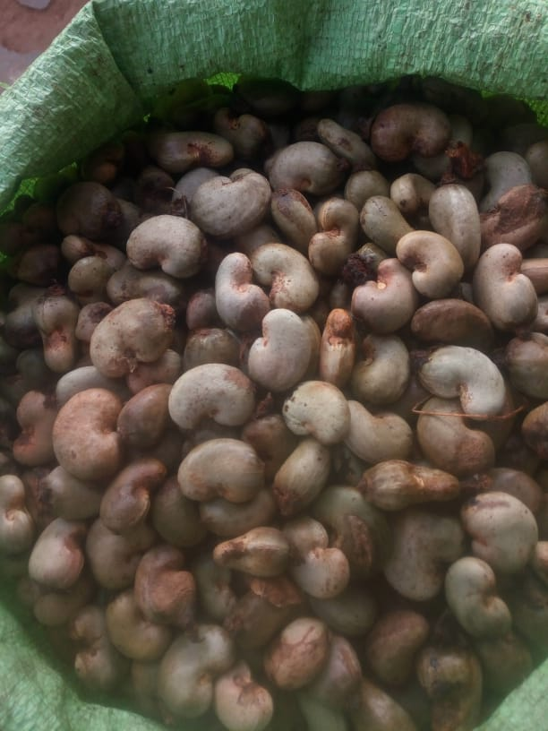

Raw Cashew Nuts(RCN) Exporting from African countries to India & Vietnam majorly as both countries are Biggest processer of RCN and re-export to worldwide or use in domestic market…. The King Group are trading RCN from IVC, Benin, Ghana, Gambia, GB, Nigeria, Tanzania, Indonesia, Cambodia and some other countries with Proper Quality, Packing, Loading and Price.

- EXPORT OF CASHEW KERNELS

The King Group offers all Specifications of Indian/Vietnam cashew kernels as per international standards. We can offer the following grades maintaining quality parameters as per CEPC / AFI standards according to the requirement of the customer/buyer in Vacuum Flaxi pack or Tin Pack.

- White Wholes (WW) :
W180 , W210 , W240 , W320 , W450 , W500
- Scorched Wholes (SW) :
SW180 , SW210 , SW240 , SW320 , SW450 , SW500
- Splits
- LWP (Long White Pieces)
- SWP (Small White Pieces)
- BB (Baby Bites)
- Dessert Wholes SSW (Scorched wholes seconds)
- DW ( Dessert wholes)

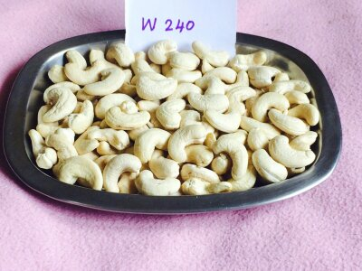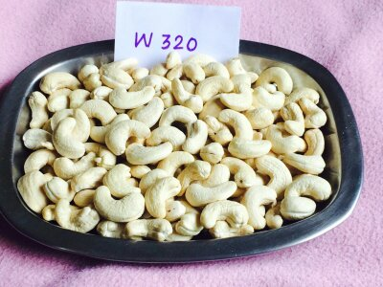

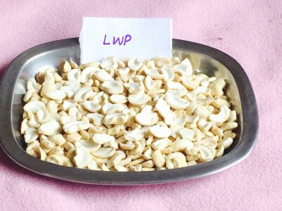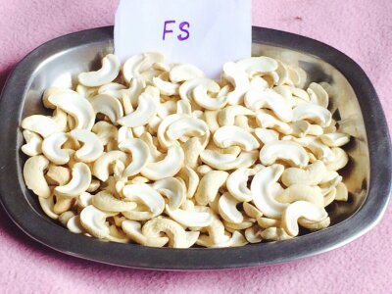

+ Soybean +

Soyabean can offer from USA, Benin, Ghana, Togo, Brazil and some more African country to India, Vietnam and China specially. The King Group have Qualitative suppliers from this Origin Countries who can provide as per Buyer’s Choice of Quality and Quantity for Human consumption or for Animal feed also.

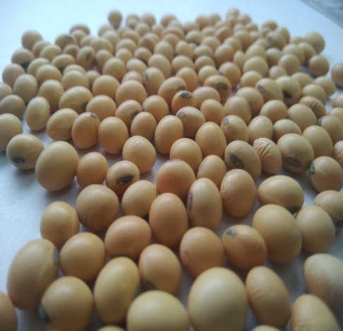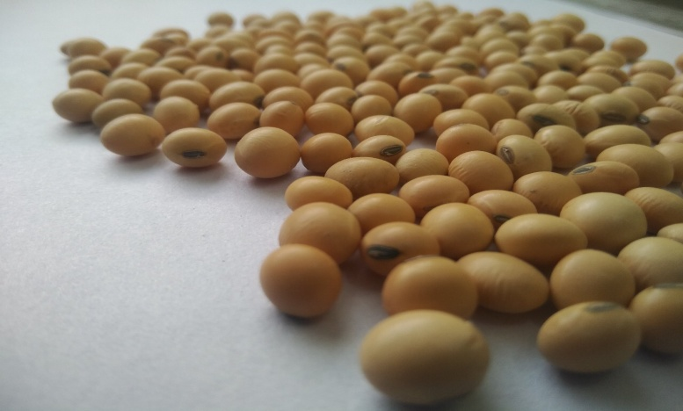
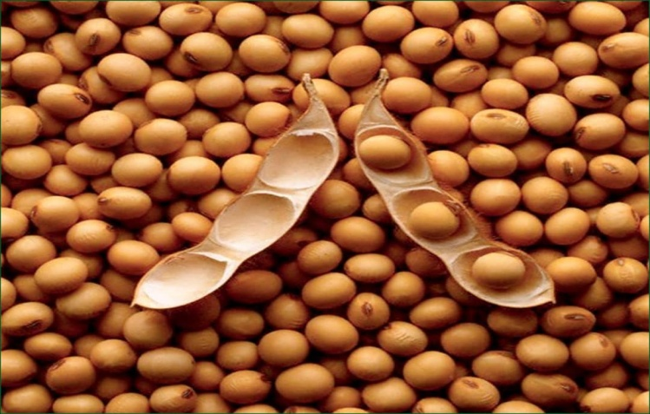

+ TILES (FLOOR & WALL) +





The King Group have relationship with many Good Production Units of Porcelain tiles/ Ceramic Tiles, Vitrified Tiles, Wall tiles, Outdoor Tiles and other Varieties with Good Quality, Designs and Competitive Price from Morbi, India. We can able to Provide with all type of Quality and Quantity of Tiles to our Valuable customers worldwide.

+ Raw Cotton +

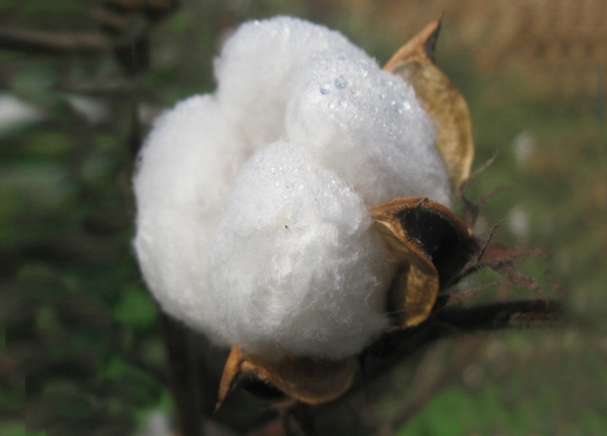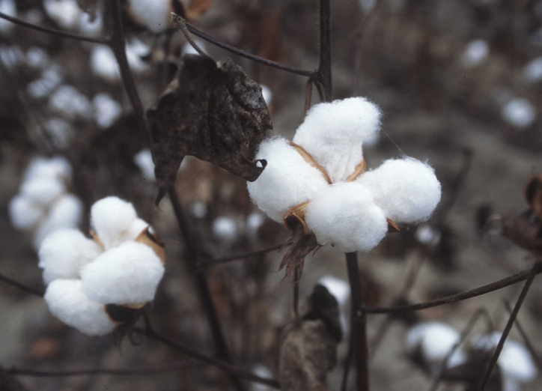

The King Group has wide experience in Cotton Industries’ Business since 2008. We are associated with Cotton Export Companies who are one of the Biggest Exporters of Cotton, Cotton Seeds and Cottonseed Oil since many years from Gujarat, India to China, Bangladesh, Vietnam, Indonesia, Malesiya and many more countries…
Also, Benin, Togo, Burkina Faso and other African Countries are known for Cotton Export and Cotton Items, and our presence in this countries give us the more option to provide Cotton to our Clients.
Our Quality Products from renowned Companies can give the full satisfaction to our valuable customers from all over the World.

+ Oilseed Products +

There are many Oilseed Products which are using worldwide for Oil production for Food. Out of this, The King Group are doing few Products which are mentioned as below,

- Peanut / Groundnut
- Sesame seed
- Cotton seed

  - Peanut/Groundnut

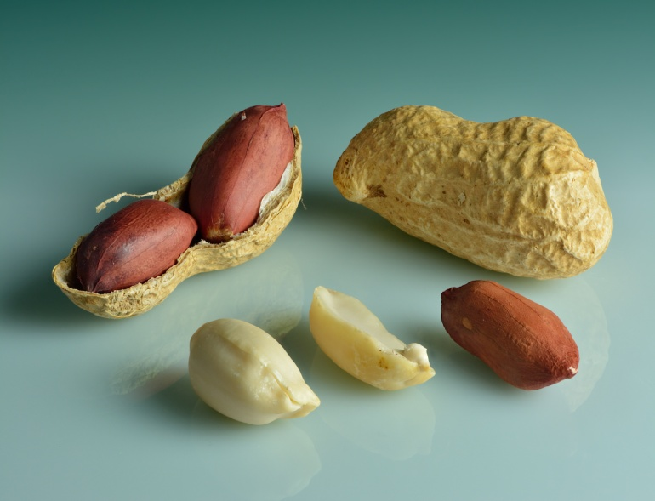

Peanut/Groundnut are majorly producing at Gujarat, India and Exporting to many Countries like China, Vietnam, Indonesia, Malaysia, Russia, Gulf Countries and European Countries also.

The King Group have Bulk of Buyers who are Purchasing Peanut/Peanut Oil & Coproducts from India. Also, we have good Peanut Processors and Oil manufacturer who can export as per require quality and quantity.

Even, many African Countries are Exporting Peanut to China and other Countries for Production of Peanut Oil and The King Group have good Sellers at African Countries also.

Sesame Seed

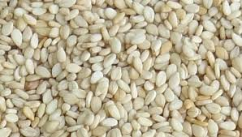

The King Group can provide Sesame Seeds from Gujarat, India in Large Quantity with the Best Quality as Gujarat is one of the Highest Sesame Seed Crop Producing State in India.
Also, We have genuine and Trustable Suppliers of Sesame Seed from Myanmar, Sudan, Burkina Faso, Senegal and other African Countries.

  - CottonSeed
The King Group have Close Contacts with Cotton Industries, we can able to Export Cottonseeds for our Customers as per Requirements. Also, WE can able to Provide the Cottonseeds from African Countries too.
Along with Cottonseed, we can provide Cottonseed Meal, Cottonseed Hulls, Cottonseed Oil and other co-related products for our customers.

+ Spices +

The King Group are dealing with many Spices from India and Vietnam Specially. This Products are,
- Indian Red Dry Chilly
- Cumin Seed
- Black Pepper
- Cinnamon
- Star Aniseed

Indian Red Dry Chilli

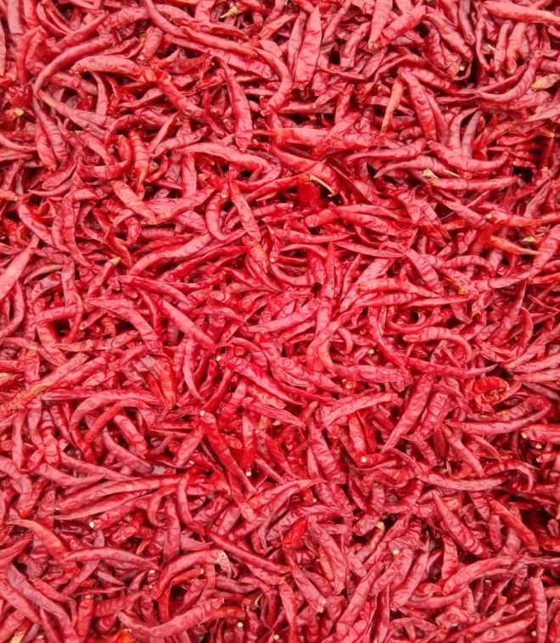
Indian Red Dry Chilly exported to Asia, Canada, and Europe, Sri Lanka, China, Philippines, Bangladesh, Middle East, South Korea, the UK, the US, and Latin America.
The King Group can provide different variety of Indian Red Dry Chilly to all over the world as per Buyer’s Requirement.

Cumin seed

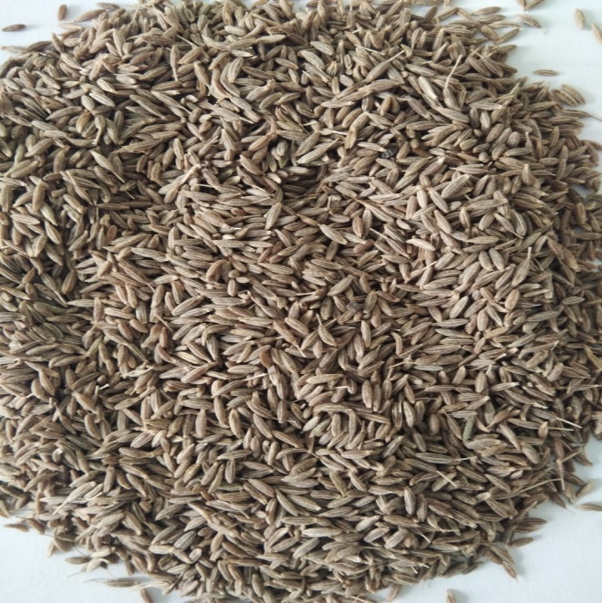
Cumin Seed generally using to prepare Garam Masala, Spice powder, Curry Powder and in many food item to enhance the taste. The King Group can provide the Cumin Seeds with the Best Quality and Affordable Price for their customers from Gujarat, India.

Black Pepper

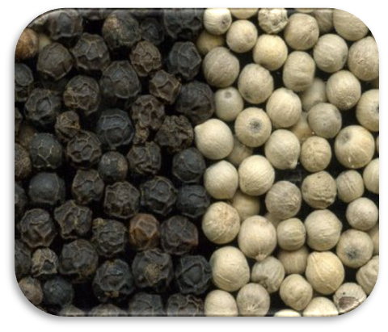
Black Pepper can produce maximum in Vietnam, India, Indonesia and Cambodia. Vietnam is the highest contributing country in export & The King Group have Lots of Suppliers from Vietnam who can provide the Black Pepper with Require Quality and Affordable Price and export to all Over the World from Vietnam.

Cinnamon
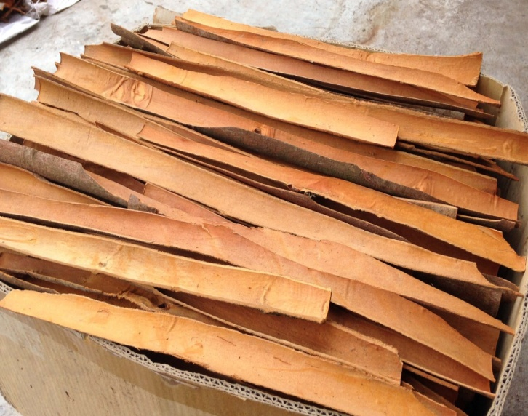
Vietnam, Indonesia, Srilanka are the major Production Countries in the world for Cinnamon. As India is a one of the Major Importer Of Cinnamon from Vietnam, The King Group can able to supply the Best Quality Cinnamon for Indian Customers from Vietnam with Affordable Price.

Star Aniseed

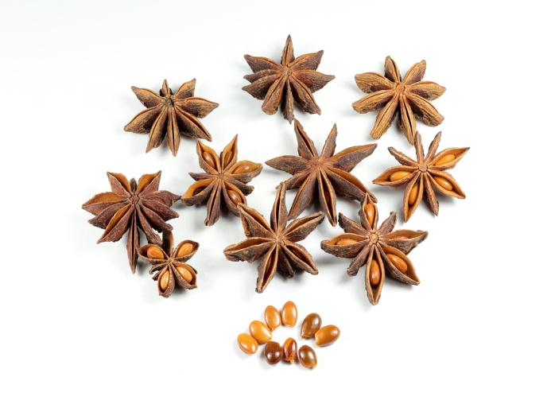
Star Aniseed is used as a spice in preparation of biryani and masala chai all over the Indian subcontinent. It is widely grown for commercial use in China, India, and most other countries in Asia.
Star anise is the major source of the chemical compound shikimic acid, a primary precursor in the pharmaceutical synthesis of the antiinfluenza drug oseltamivir (Tamiflu).

The King Group can provide Star Aniseed from Vietnam to India as per the Requirement in Good Price.

